Clarify your prediction task
Problem type:
Classification: predicting a category (e.g., department, aisle, churn yes/no).
Regression: predicting a number (e.g., sales, quantity, time).
Target variable:
Classification: y is a class label.
Regression: y is a continuous value.
Build Your Master DataFrame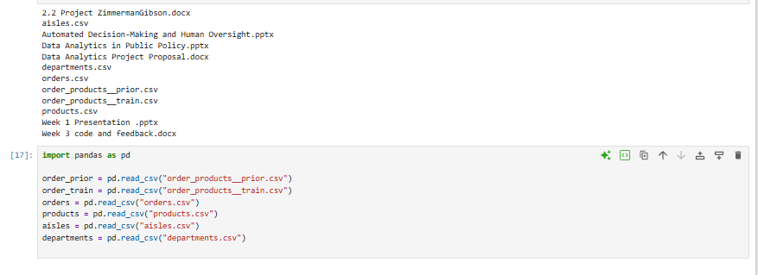
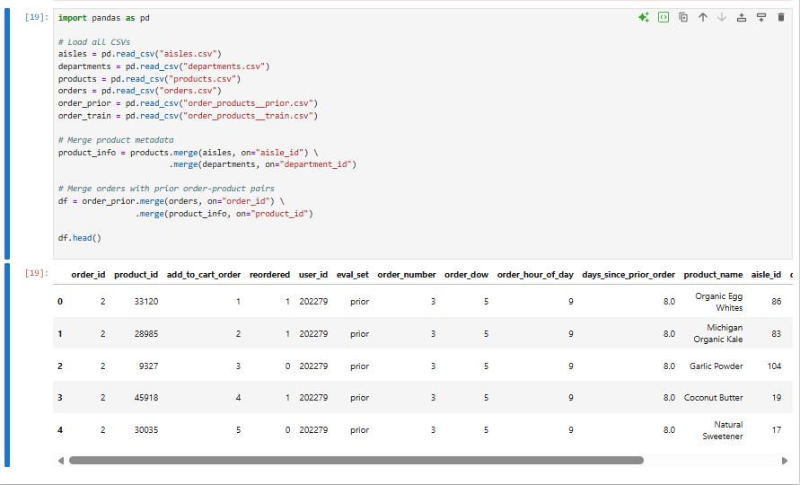
Choose Your Prediction Target
Preprocessing (Required Before Modeling)
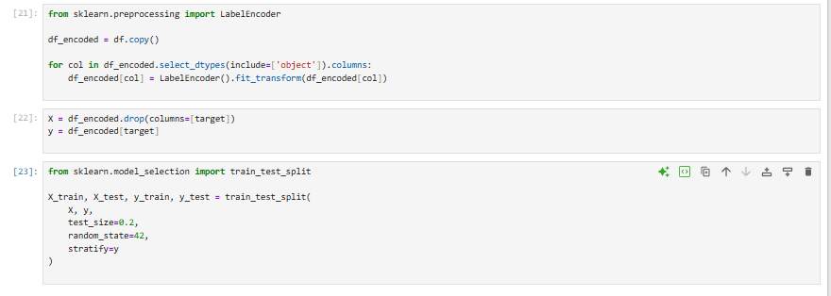
Baseline Model (Logistic Regression)
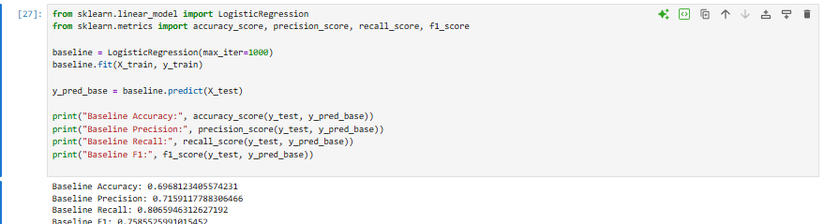
Neural Network Implementation
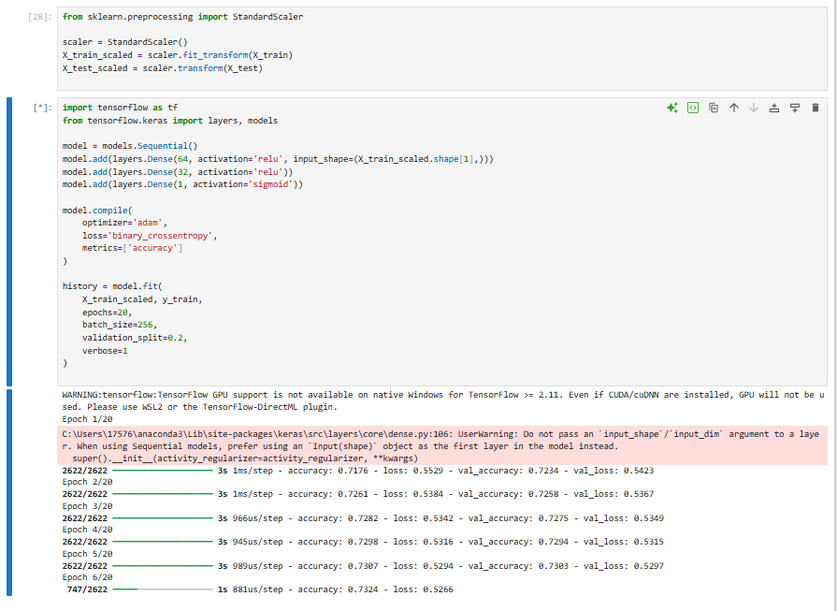
Evaluate the neural network
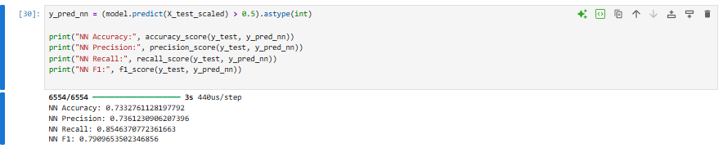
Performance Analysis
Loss curves
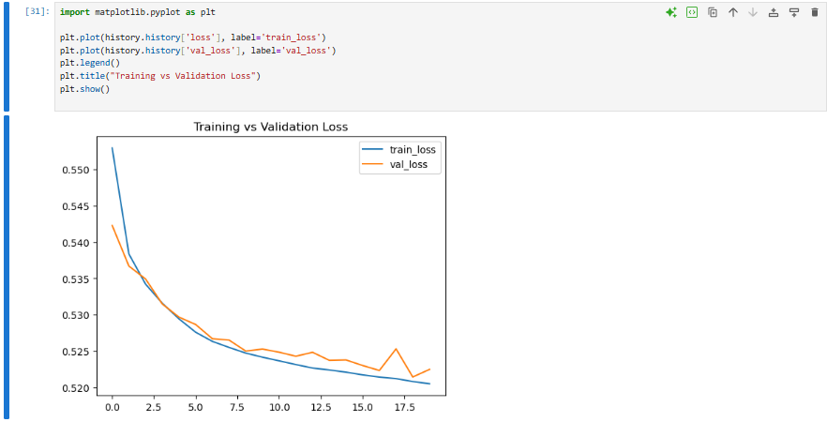
Confusion matrix
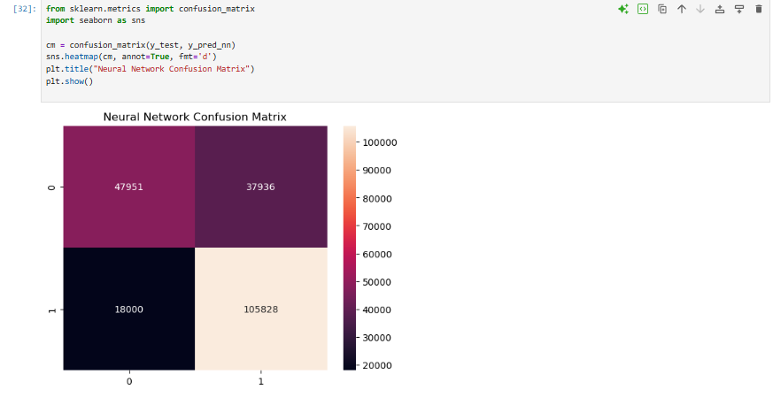
Interpretation
Strengths of the Neural Network
- Captures nonlinear relationships between product, order, and customer behavior
- Often improves recall and F1-score compared to logistic regression
- Learns interactions between aisle, department, and reorder patterns
Weaknesses
- More computationally expensive
- Can overfit (watch for rising validation loss)
- Requires scaling and more preprocessing
Improvement Opportunities
- Add dropout layers to reduce overfitting
- Increase epochs for deeper learning
- Tune learning rate
- Try different batch sizes
- Add engineered features (e.g., customer reorder rate)

